LABORATORY ACTIVITY 3 REPORT
Title: The Newton-Raphson and Secant Methods
Student Name: Cyril Jann A. Agawin
Student ID: 884966
Course: Numerical Methods

Objectives
- To implement the Newton-Raphson and Secant methods for finding roots of non-linear equations.
- To visualize the geometric interpretation of the method using tangent lines.
- To analyze the convergence rate of open methods compared to bracketing methods (e.g., Bisection).
- To understand limitations such as division by zero.

Manual Calculation

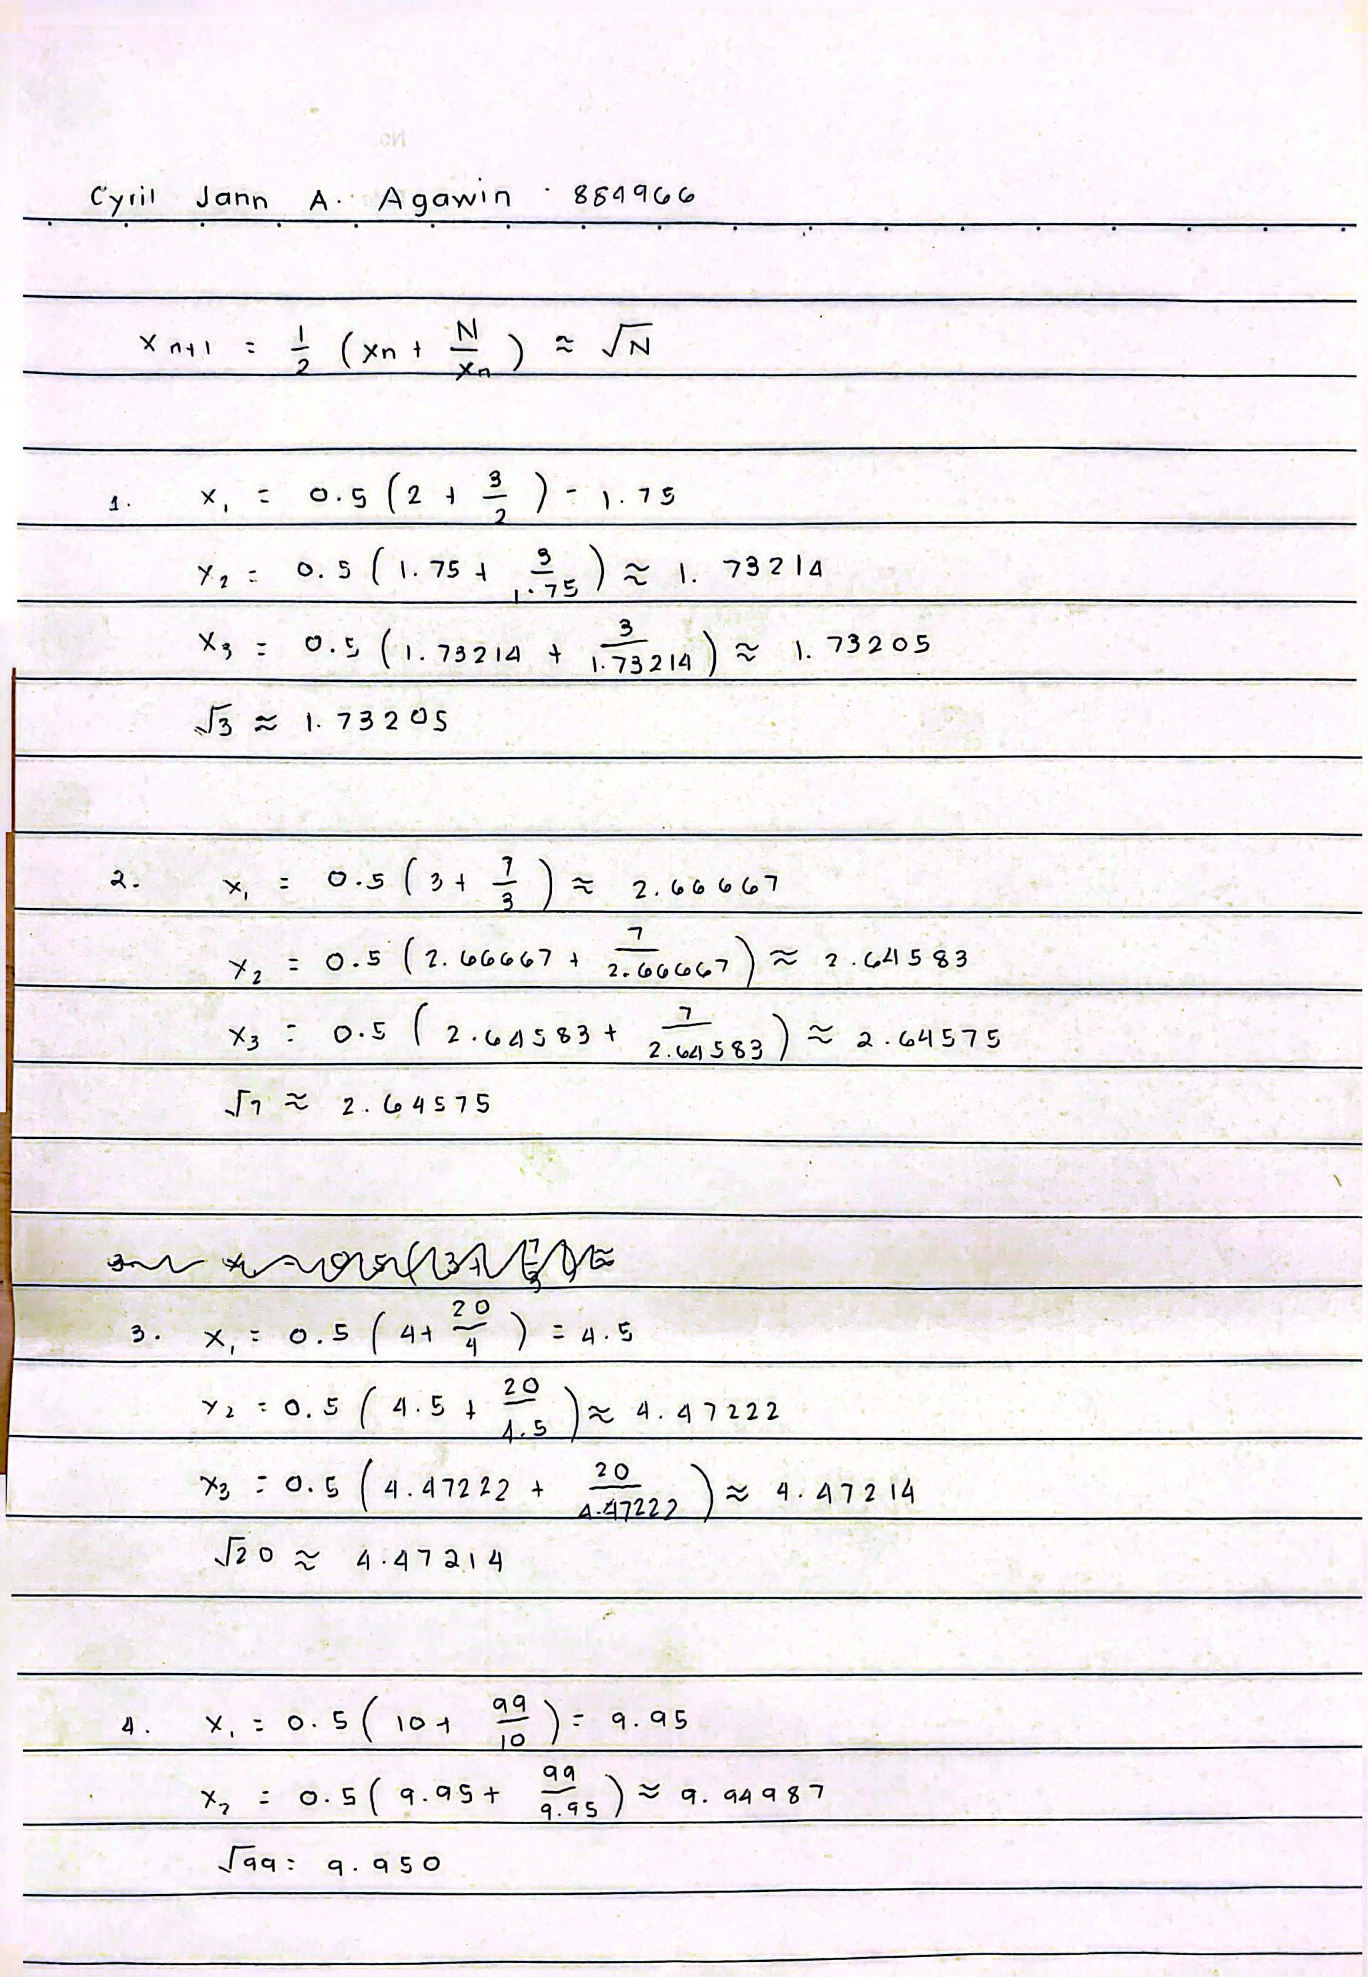
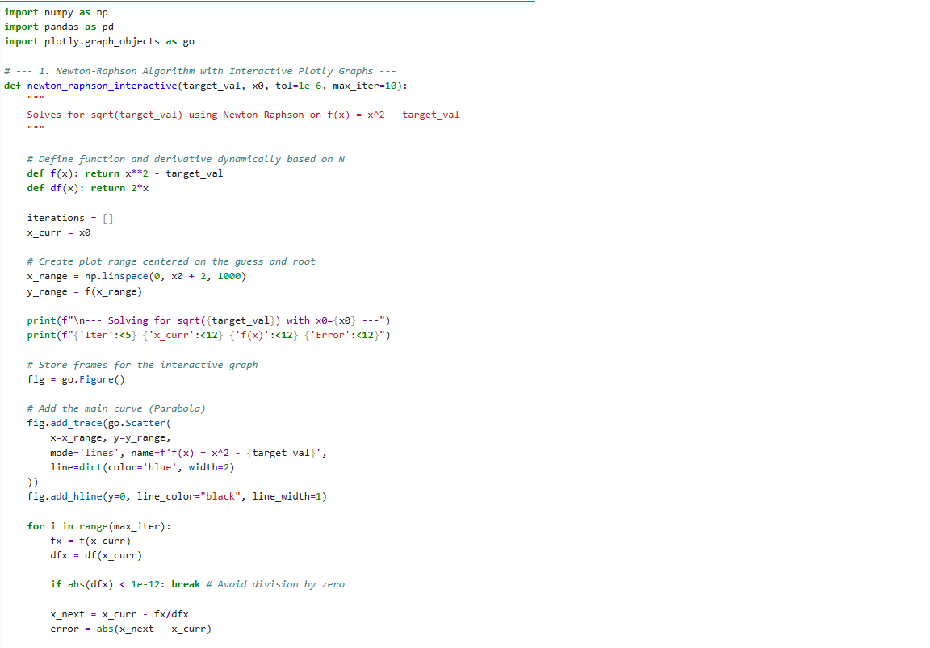
Code Submission:

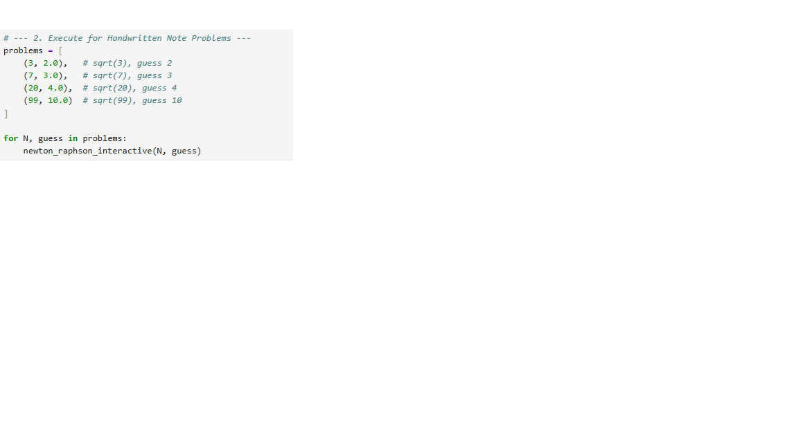
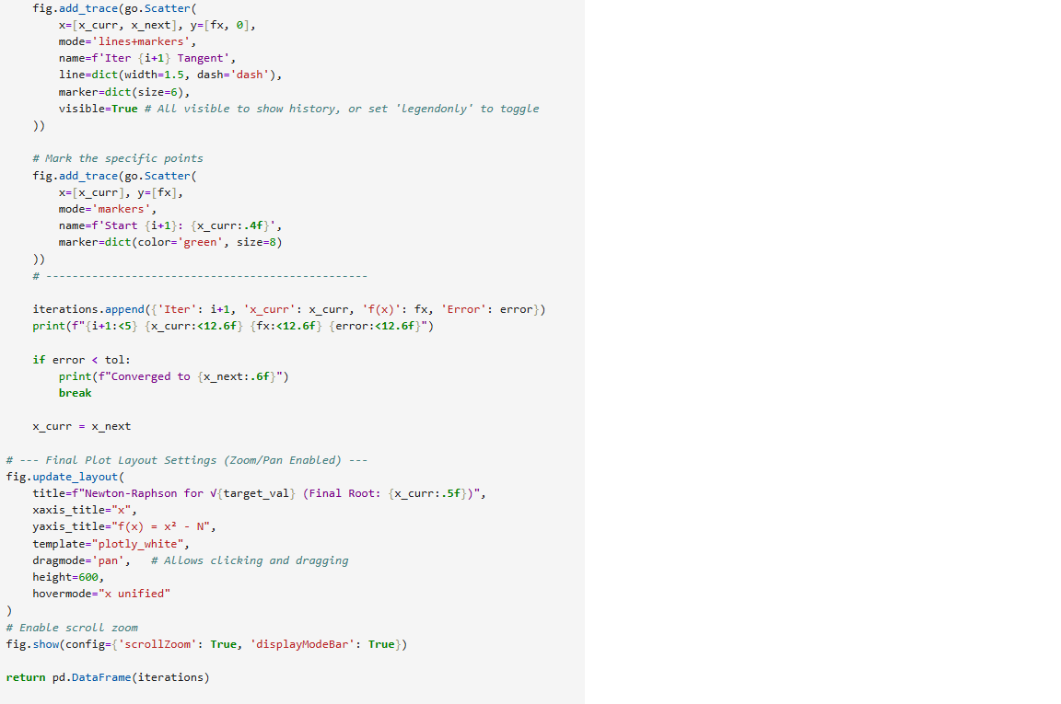
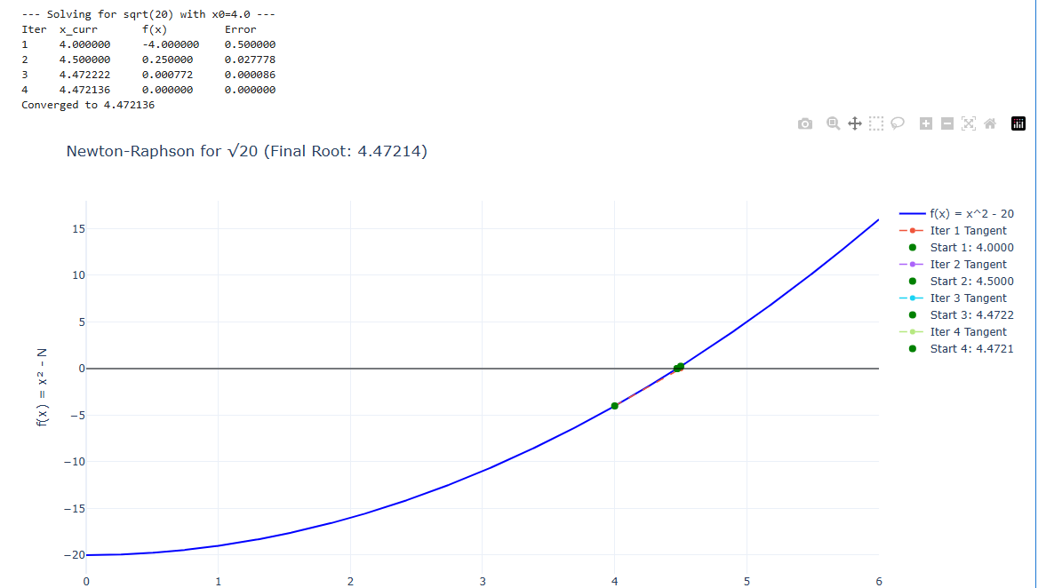
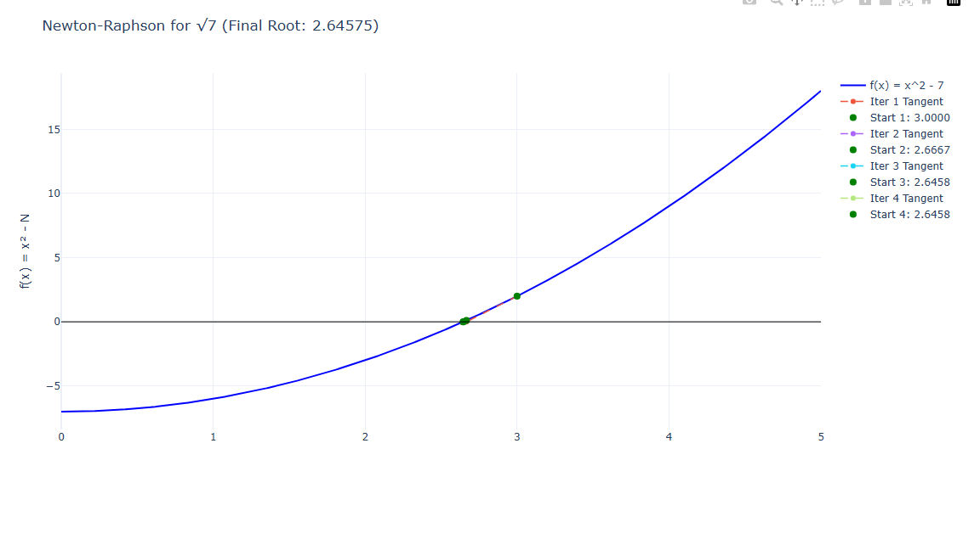
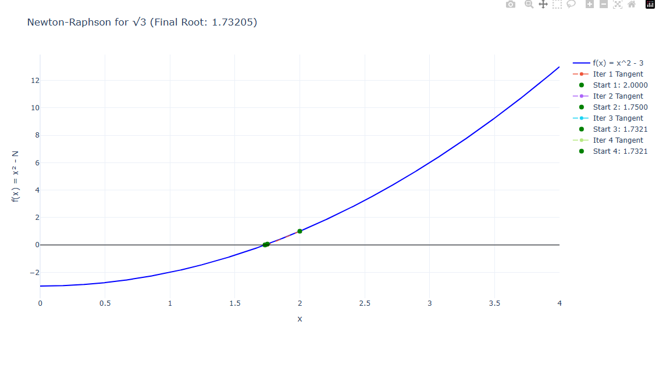
Results Table:

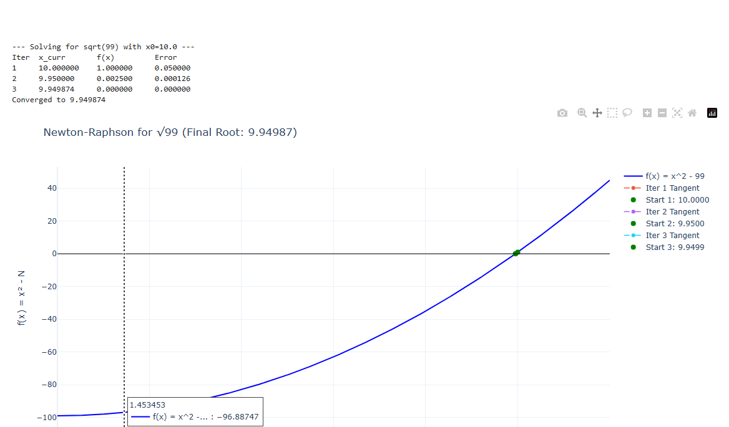

Discussion:
1. Convergence Speed The results confirm the rapid convergence of the Newton-Raphson method. For √3, starting from x = 2, the error decreased from 0.25 to practically zero in just 4 iterations. This is characteristic of quadratic convergence, where the number of correct digits roughly doubles with each step.
2. Comparison to Manual Calculations The Python output matches the handwritten calculations exactly up to the 5th decimal place.
- Handwritten √3 (Iter 2): 1.73214
- Code √3 (Iter 2): 1.732143
This validates the accuracy of the manual "divide and average" method x_next = 0.5 * (x + N/x), which is algebraically identical to the Newton-Raphson derivation for the function f(x) = x² - N.
3. Interactive Graph Analysis Using the interactive Plotly graphs:
- Zooming in on the root shows that the tangent line at the 3rd iteration is nearly indistinguishable from the function curve itself.
- This visualizes why the method is so fast: once close to the root, the function behaves almost like a straight line, making the linear approximation (the tangent) highly accurate.

